COMPUTER ORGANIZATION AND ASSEMBLY LANGUAGE

LAB NO 7

ALEEZA RIZVI

2025

**Task No 7**

1. **Write an assembly language program that find the square of a number entered by user. Print the result on screen.**

**CODE**

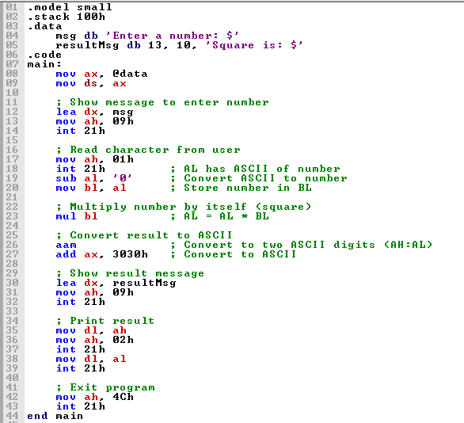

**Output**

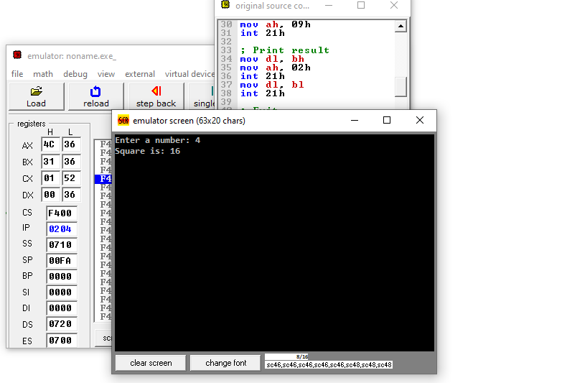

1. **Write an assembly language program that find the cube of a number entered by user**

**CODE**

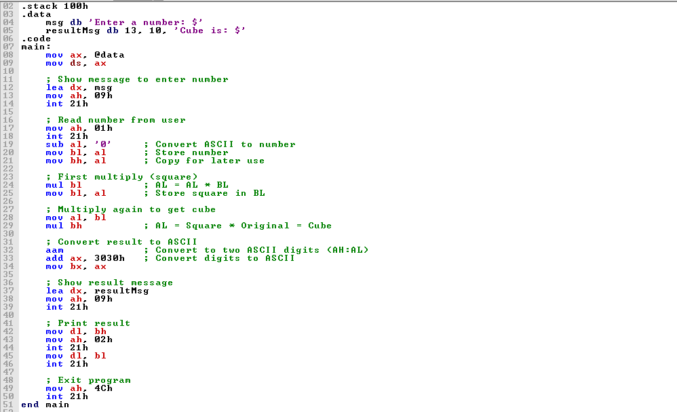

**Output**

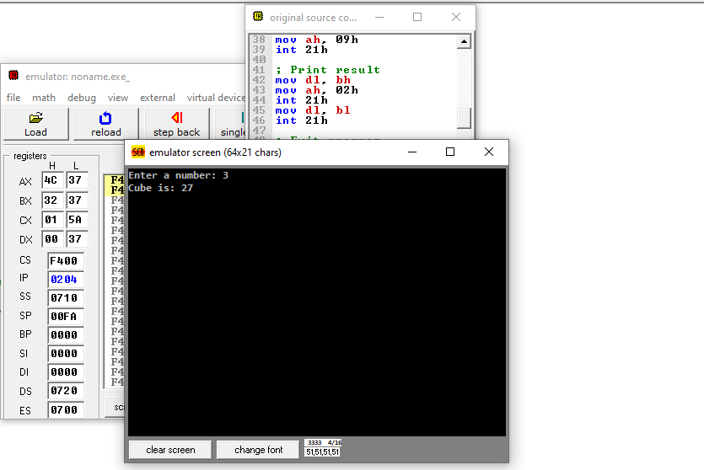

1. **Perform multiplication of two numbers entered by user. Print the result on screen.**

**CODE**

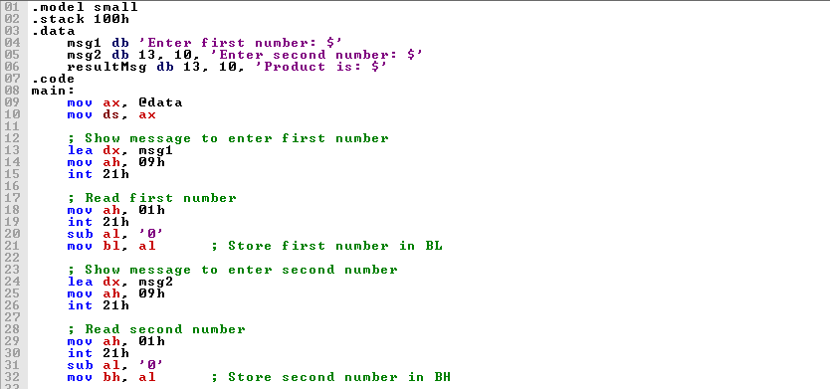

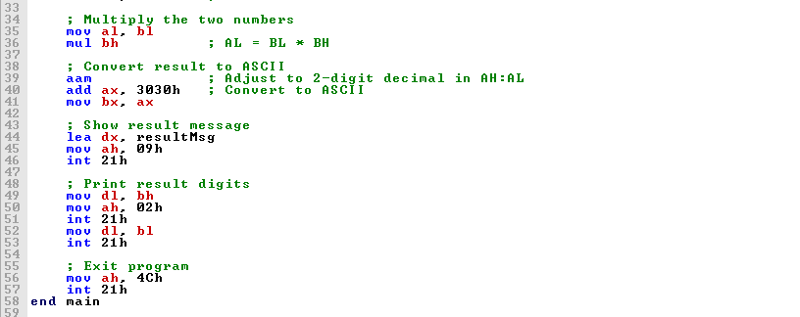

**Output**

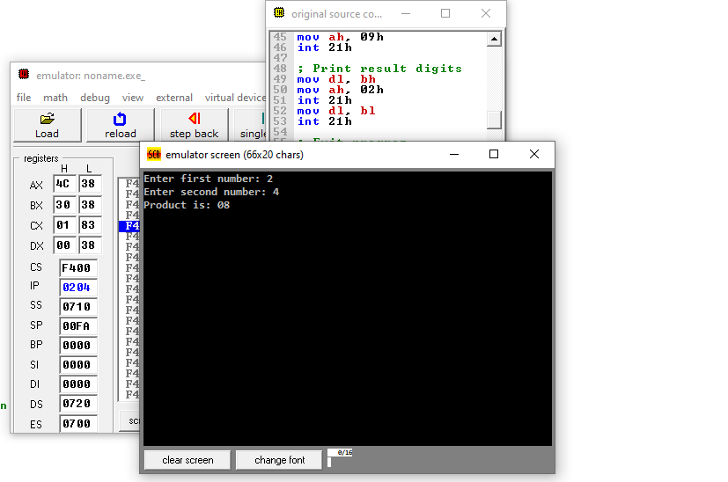

1. **Write an assembly language program that finds the area of a triangle.**

**CODE**

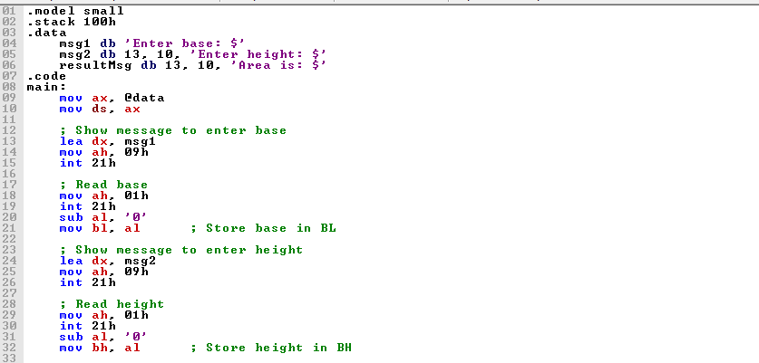

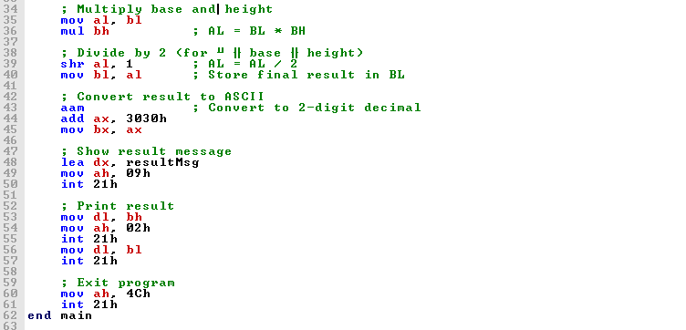

**Output**

